Cloud watch agent
Q 1. Install Cloud watch agent in Windows & Linux, create Utilization Alarms
Launch EC2 instance

Connect ec2 instance with session manager
Step1
(New-Object System.Net.WebClient).DownloadFile("https://s3.amazonaws.com/amazoncloudwatch-agent/windows/amd64/latest/amazon-cloudwatch-agent.msi", "$env:TEMP\amazon-cloudwatch-agent.msi")
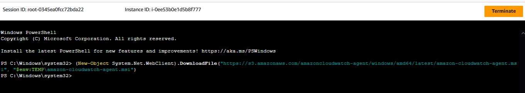
Step2
Start-Process msiexec.exe -Wait -ArgumentList "/i $env:TEMP\amazon-cloudwatch-agent.msi"
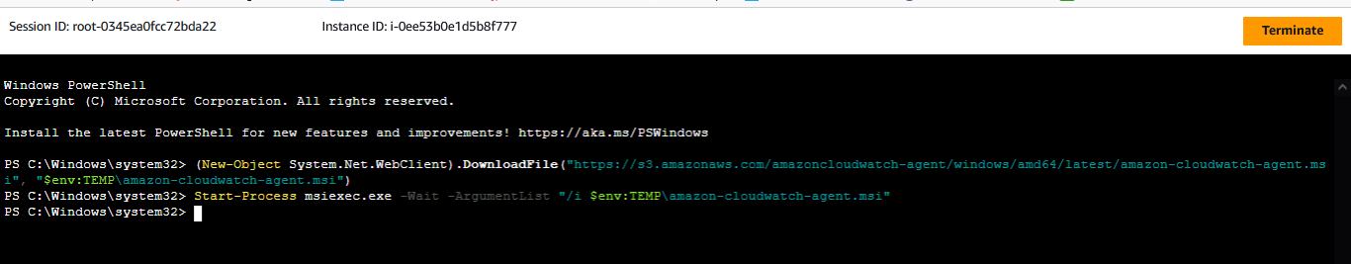
Step3 : Change directory
cd "C:\Program Files\Amazon\AmazonCloudWatchAgent"
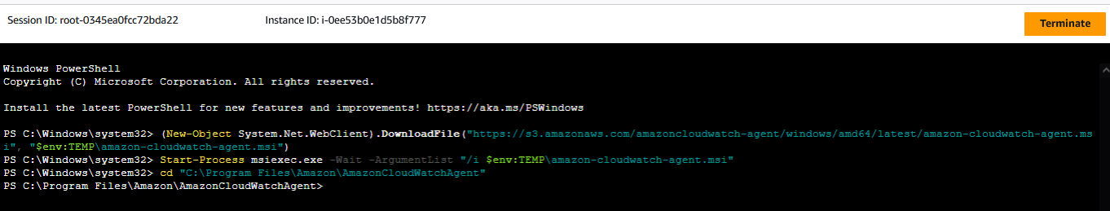

Step4 : Cloudwatchagent configuration
.\amazon-cloudwatch-agent-config-wizard.exe
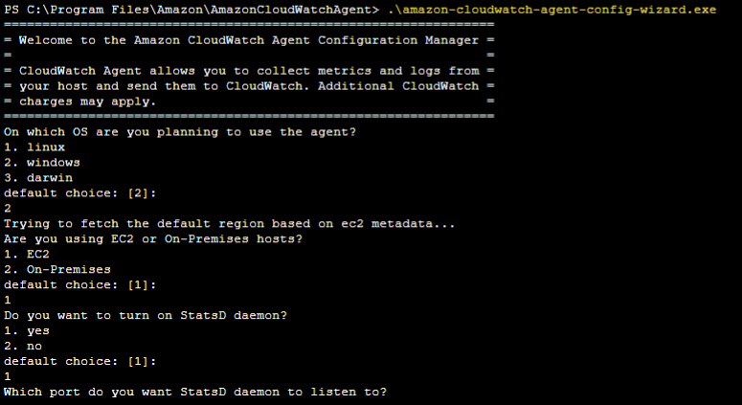
Step5: configuring config.json
& "C:\Program Files\Amazon\AmazonCloudWatchAgent\amazon-cloudwatch-agent-ctl.ps1" -a fetch-config -m ec2 -s -c file:"C:\Program Files\Amazon\AmazonCloudWatchAgent\config.json"
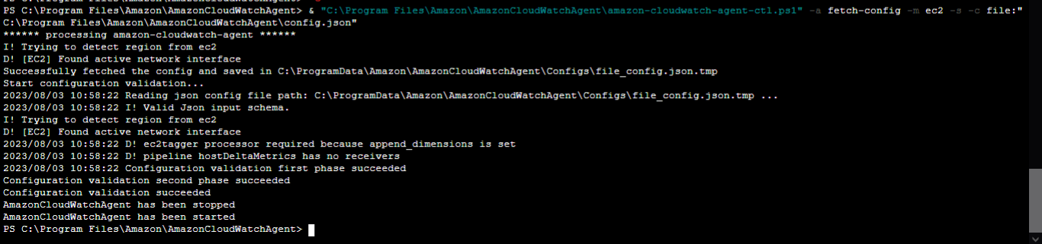
Step6: start cloudwatch agent
Start-Service -Name AmazonCloudWatchAgent

Step 7 : checking service status
Get-Service -Name AmazonCloudWatchAgent
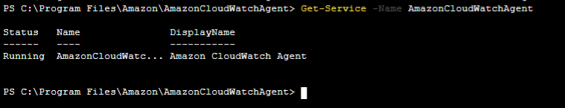

Step 4
PS C:\Program Files\Amazon\AmazonCloudWatchAgent> .\amazon-cloudwatch-agent-config-wizard.exe
================================================================
= Welcome to the Amazon CloudWatch Agent Configuration Manager =
= =
= CloudWatch Agent allows you to collect metrics and logs from =
= your host and send them to CloudWatch. Additional CloudWatch =
= charges may apply. =
================================================================
On which OS are you planning to use the agent?
1. linux
2. windows
3. darwin
default choice: [2]:
2
Trying to fetch the default region based on ec2 metadata...
Are you using EC2 or On-Premises hosts?
1. EC2
2. On-Premises
default choice: [1]:
1
Do you want to turn on StatsD daemon?
1. yes
2. no
default choice: [1]:
1
Which port do you want StatsD daemon to listen to?
default choice: [8125]

What is the collect interval for StatsD daemon?
1. 10s
2. 30s
3. 60s
default choice: [1]:
3
What is the aggregation interval for metrics collected by StatsD daemon?
1. Do not aggregate
2. 10s
3. 30s
4. 60s
default choice: [4]:
4
Do you have any existing CloudWatch Log Agent configuration file to import for migration?
1. yes
2. no
default choice: [2]:
2
Do you want to monitor any host metrics? e.g. CPU, memory, etc.
1. yes
2. no
default choice: [1]:
1
Do you want to monitor cpu metrics per core?
1. yes
2. no
default choice: [1]:
1
Do you want to add ec2 dimensions (ImageId, InstanceId, InstanceType, AutoScalingGroupName) into all of your metrics if the info is available?
1. yes
2. no
default choice: [1]:
1
Do you want to aggregate ec2 dimensions (InstanceId)?
1. yes
2. no
default choice: [1]:
1
Would you like to collect your metrics at high resolution (sub-minute resolution)? This enables sub-minute resolution for all metrics, but you can customize for specif
ic metrics in the output json file.
1. 1s
2. 10s
3. 30s
4. 60s
default choice: [4]:
4
Which default metrics config do you want?
1. Basic
2. Standard
3. Advanced
4. None
default choice: [1]:
1
Current config as follows:
{
"metrics": {
"aggregation_dimensions": [
[
"InstanceId"
]
],
"append_dimensions": {
"AutoScalingGroupName": "${aws:AutoScalingGroupName}",
"ImageId": "${aws:ImageId}",
"InstanceId": "${aws:InstanceId}",
"InstanceType": "${aws:InstanceType}"
},
"metrics_collected": {
"LogicalDisk": {
"measurement": [
"% Free Space"
],
"metrics_collection_interval": 60,
"resources": [
"*"
]
},
"Memory": {
"measurement": [
"% Committed Bytes In Use"
],
"metrics_collection_interval": 60
},
"statsd": {
"metrics_aggregation_interval": 60,
"metrics_collection_interval": 60,
"service_address": ":8125"
}
}
}
}
Are you satisfied with the above config? Note: it can be manually customized after the wizard completes to add additional items.
1. yes
2. no
default choice: [1]:
1
Do you want to monitor any customized log files?
1. yes
2. no
default choice: [1]:
2
Do you want to monitor any Windows event log?
1. yes
2. no
default choice: [1]:
2
Saved config file to config.json successfully.
Current config as follows:
{
"metrics": {
"aggregation_dimensions": [
[
"InstanceId"
]
],
"append_dimensions": {
"AutoScalingGroupName": "${aws:AutoScalingGroupName}",
"ImageId": "${aws:ImageId}",
"InstanceId": "${aws:InstanceId}",
"InstanceType": "${aws:InstanceType}"
},
"metrics_collected": {
"LogicalDisk": {
"measurement": [
"% Free Space"
],
"metrics_collection_interval": 60,
"resources": [
"*"
]
},
"Memory": {
"measurement": [
"% Committed Bytes In Use"
],
"metrics_collection_interval": 60
},
"statsd": {
"metrics_aggregation_interval": 60,
"metrics_collection_interval": 60,
"service_address": ":8125"
}
}
}
}
Please check the above content of the config.
The config file is also located at config.json.
Edit it manually if needed.
Do you want to store the config in the SSM parameter store?
1. yes
2. no
default choice: [1]:
2
Please press Enter to exit...

Program exits now.
PS C:\Program Files\Amazon\AmazonCloudWatchAgent>

